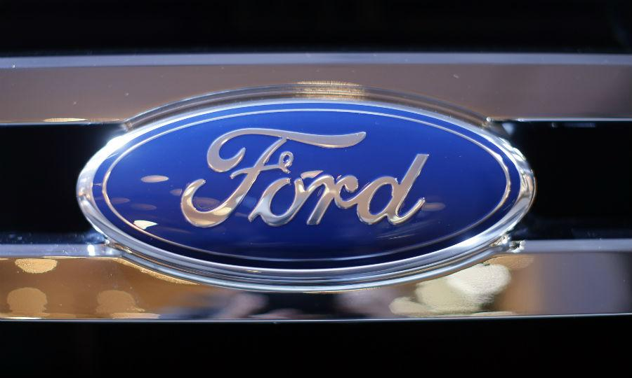
A Texas software company that says it helped Ford Motor Co. significantly reduce warranty costs and bring vehicles to market faster has filed a federal lawsuit accusing the automaker of stealing its intellectual property.
The company, Versata, on Wednesday asked a U.S. District Court judge in Texas for an injunction against Ford, which began using the software in 1998 as part of its product-development process. Ford terminated the $8.45 million-a-year contract at the end of last year and instead began using a program it developed in-house based on Versata’s proprietary software, the lawsuit says.
Versata, which is seeking unspecified damages, says a patent that Ford received in 2014 on the internally developed software was actually based on the technology it had licensed to Ford, known as Automotive Configuration Manager. Versata says its software identifies incompatible parts in millions of possible vehicle configurations, helping automakers avoid recalls or other problems.
“What they submitted to the patent office contained our stolen code,” Lanny Davis, a lawyer for Versata, told Automotive News on Thursday. “The patent, as far as we’re concerned, is bogus.”
Davis later clarified his comment to say that Ford’s patent application “was derived from” Versata’s code without directly copying it.
Versata, in its injunction request, wants Ford to stop using the internally developed software.
Ford has until June 29 to respond to the lawsuit, which was originally filed May 7. In a statement today, it denied using or infringing on Versata’s intellectual property.
The lawsuit says the same Ford employees who used ACM developed the replacement software and that Ford, in violation of the two companies’ contract, denied a request from Versata to examine the automakers’ servers and software.
In February, Ford filed a sealed federal complaint against Versata in Michigan asking for a judgment affirming that the replacement software did not infringe on Versata’s intellectual property. The judge in that case ordered the complaint unsealed but has not issued a ruling.
“Versata’s Texas case is a retaliatory attempt to avoid the lawsuit in Michigan, where Ford’s software was developed and used,” Ford said in its statement today. “Ford will move to dismiss or transfer the Texas case to Michigan.”
In a March filing for the Texas case, Ford said its engineers began developing replacement software in 2010 after Versata had declared ACM “obsolete.” At the heart of the replacement software, it said, was an invention it called the “super configurator” -- technology that determines which vehicle configurations sell the best.
“Ford’s invention approaches vehicle configuration very differently, and more efficiently, than” Versata’s technology, Ford said in the filing.
Versata says other automakers using its software include General Motors, Nissan Motor, Fiat Chrysler, Toyota Motor, Hyundai-Kia, Volvo and Jaguar.
“Our intellectual property is the lifeblood of our company, and we must protect it all costs,” Mike Richards, the president of global automotive business at Versata’s parent company, Trilogy Inc., said on a conference call with reporters.
Richards, a former general marketing manager of Ford’s Lincoln Mercury division and general sales manager of Ford’s customer service division, said Versata’s software “has allowed Ford to increase profits by hundreds of millions or more likely billions of dollars during our relationship.”

